Chapter 7

# Try It Yourself: Estimate the Probability of an Event

## StatCrunch Instructions

1. Open a blank data sheet.
2. Data → Simulate → Binomial
3. Number of Rows → 100
4. Number of Columns → 1
5. Binomial parameters → n → 100; p → 0.5
6. Under Seeding:
   1. Select “Use fixed seed”
   2. Type 777 in Seed

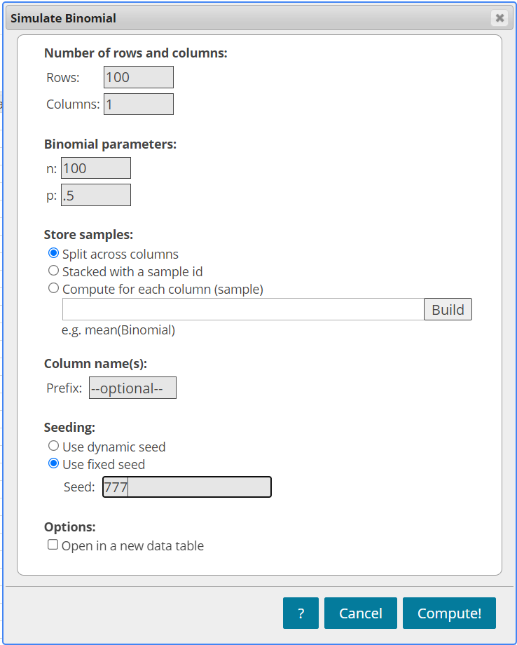

1. Click Compute!
2. Rename the header of the new column of data: Heads
3. Stat → Summary Stats → Columns
4. Select Column(s): Heads
5. In the “Where:” box, enter:

*“Heads = 60”*

1. Statistics → n
2. Click Compute!